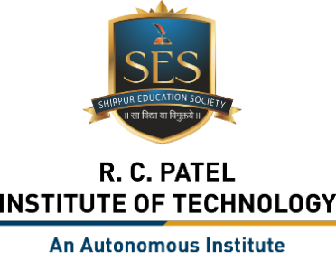
R. C. Patel Institute of Technology, Shirpur
Department of Artificial Intelligence and Machine Learning
Vision
Fostering technical excellence in Artificial Intelligence and Machine Learning through ethics, innovative research, and sustainable education.
Mission
M1: Innovative and interactive learning processes with high-quality instructional programs in Artificial Intelligence and Machine Learning.

M2: Fostering a collaborative scientific temper among students with ethical responsibility towards society in AI and ML applications.

M3: Preparing students from diverse backgrounds to develop aptitude for employment, entrepreneurship, and research in AI and ML with a spirit of professionalism.

