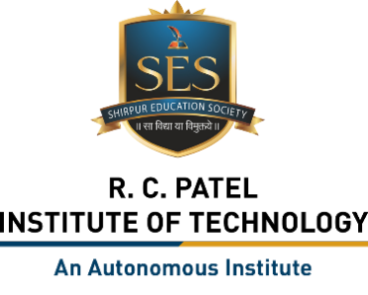
R. C. Patel Institute of Technology, Shirpur
Department of Computer Science & Engineering (Data Science)

Vision
To provide cutting-edge Computer Engineering education in Data Science while instilling socio-moral values.

Mission
M1: To deliver state-of-the-art, ICT-enabled teaching and learning to achieve excellence in Data Science education.
M2: To develop professionally competent Data Science Engineers, meeting evolving industrial and societal needs.
M3: To prepare employable professionals with ethical values and a commitment to professional and social responsibility.

